Linux Command Documentation – LS Command

ls
Description:
ls is used to list files and directories present in the current working directory. It helps users understand what files or folders exist.
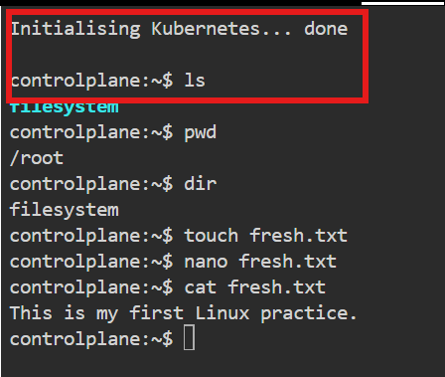
Explanation:
Displays all files and directories in the current directory.

pwd
Description:
Prints the present working directory (current location).
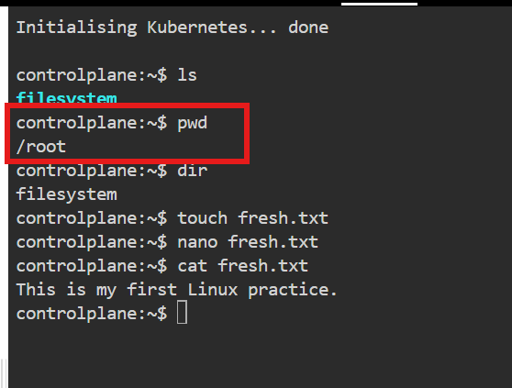
Explanation:
Shows the absolute path of the current directory.

Dir
Description:
The dir command is used to list the files and directories present in the current directory or a specified directory.
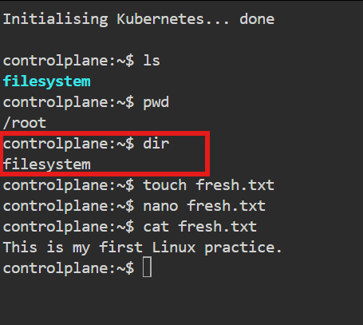
Explanation:
The dir command displays directory contents in a simple, column-based format.

whoami : Displays the effective username of the current session

:wq

touch
Description:
Creates an empty file or updates the timestamp of an existing file.
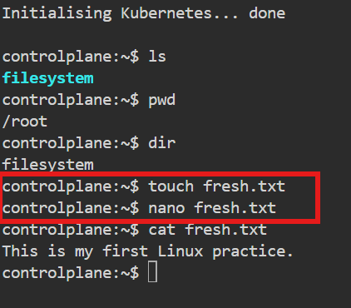
Explanation: Creates a new file named data.txt

nano
Description:
nano is a simple, user-friendly text editor used in Linux to create and edit files directly from the terminal.
Explanation:
The nano editor is easy to use compared to editors like vi or vim. It opens files in an interactive screen where users can type, edit, and save content without memorizing complex commands.

cat
Description:
Displays the contents of a file.
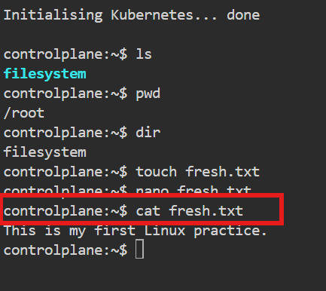
Explanation:
Prints the file content to the terminal.
Cd
Description:
The cd (change directory) command is used to navigate between directories in the Linux filesystem.
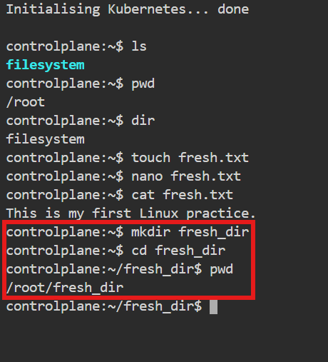
Explanation:
The cd command allows users to move from one directory to another.

mkdir
Description:
Creates a new directory.
Explanation:
Creates a directory named logs.
Whoami
Description:
The whoami command displays the username of the currently logged-in user.
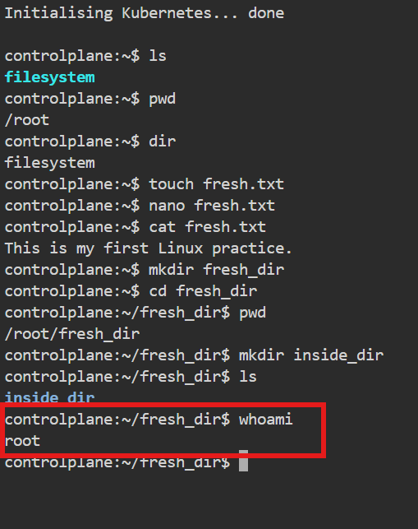
Explanation:
This command is used to confirm which user account is currently active in the terminal session. It is especially useful in environments where multiple users exist or when switching users using su or sudo.

mv
Description:
The mv (move) command is used to move files or directories from one location to another. It is also commonly used to rename files or directories.
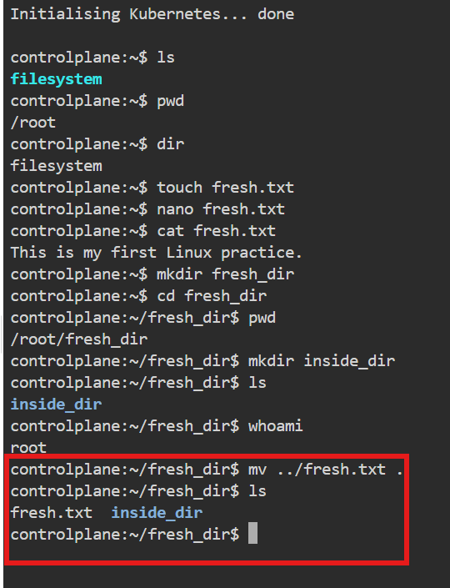
Explanation:The mv command changes the location or name of a file or directory without creating a copy. When used for renaming, the file content remains the same; only the name changes. This command is frequently used in file management and deployment activities.

rmdir
Description:
The rmdir command is used to remove (delete) empty directories in Linux.
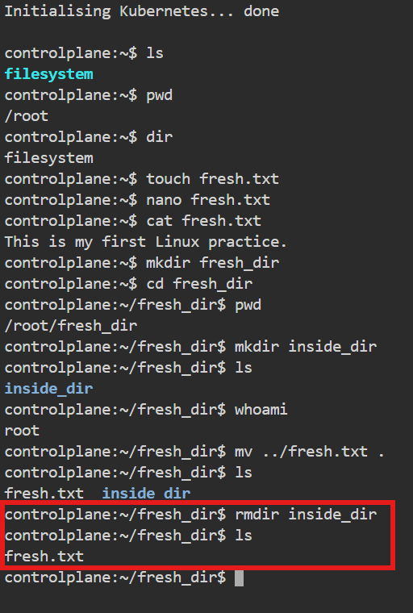
Explanation:
The rmdir command deletes a directory only if it is empty (contains no files or subdirectories). It is mainly used for cleaning up unused directory structures. If the directory contains any files, the command will fail and show an error.

rm -rf
Description:
The rm -rf command is used to forcefully delete files and directories, including all their contents, without asking for confirmation.
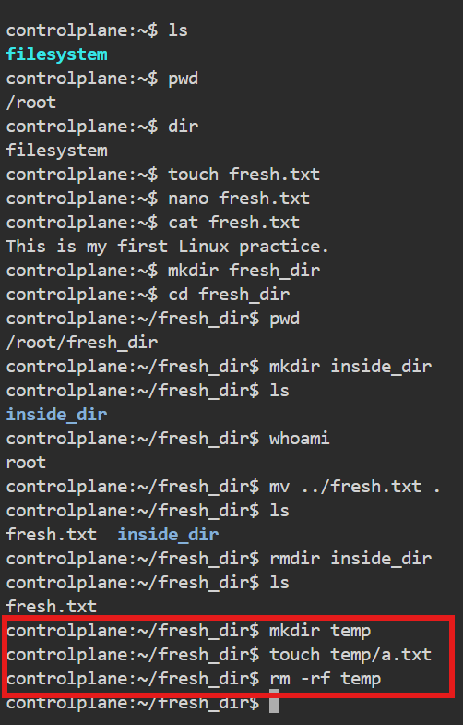
Explanation:
• rm → remove files or directories
• -r → recursively deletes directories and their contents
• -f → forces deletion and ignores warnings or permission prompts

cd & cp
cd

Description:
The cd (change directory) command is used to navigate between directories in the Linux filesystem.

Explanation:
cd allows the user to move from one directory to another. Most file and directory operations in Linux depend on the current working directory, so cd is one of the most frequently used commands. It does not produce output when executed successfully.
cp

Description:
The cp (copy) command is used to copy files or directories from one location to another.

Explanation:
The cp command creates a duplicate of a file or directory while keeping the original intact. It is commonly used for backups, file sharing, and deployment tasks.
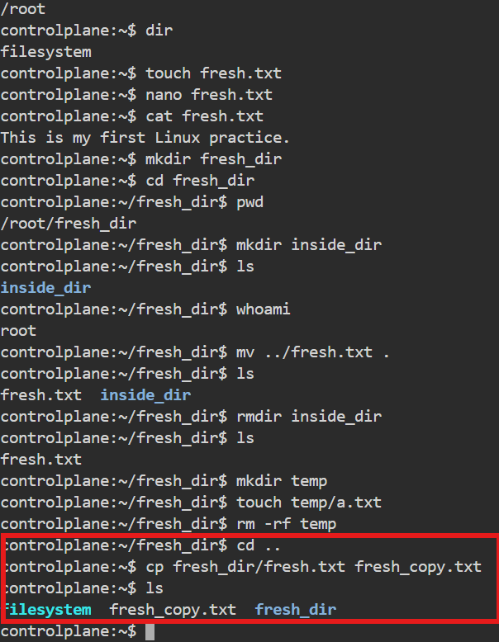

mv
Description:
The mv (move) command is used to move files or directories from one location to another. It is also used to rename files or directories.

Explanation:
The mv command changes the location or name of a file or directory without creating a copy. When a file is renamed using mv, the content of the file remains unchanged. This command is widely used in file management, backups, and deployment activities. Explanation:

wget
Description:
wget is a command-line utility used to download files from the internet using protocols such as HTTP, HTTPS, and FTP.

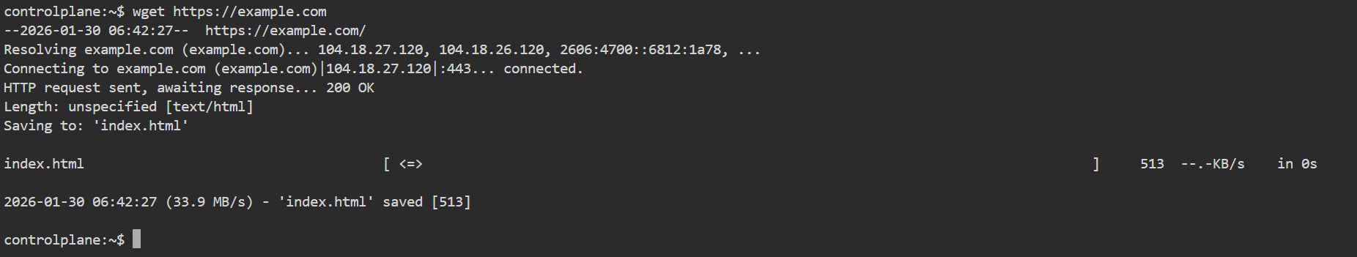
Explanation:
The wget command allows users to download files directly from a URL without opening a browser. It is commonly used in Linux servers and DevOps environments to download software packages, scripts, configuration files, and application artifacts.

ping

What is ping?
ping is a Linux command used to check network connectivity between your system and another system (server/website).

Why ping?
It helps to verify whether a server or website is reachable and how fast the network response is.

history
Shows previous commands.

sudo useradd username:
*It creates a new user and to add the user to the system.
*It does NOT set password automatically.

sudo adduser username:
*Creates a new user (interactive). Beginner-friendly way to add user.
*Creates home folder, Asks password, Sets user details

cat /etc/passwd:
==> /etc/passwd is a system file in Linux that stores user account information.
*It does NOT store passwords anymore (for security reasons). *It stores user details.
*cat displays the list of all users in the system.

sudo userdel username
* It is used to delete the user , removes unused users.
* Removes a user, but may fail without sudo because admin rights are usually required.
Username diva is deleted.

Su – username

Switches to another user account and loads their environment

Passwd username
Sets or changes the password for a user.

sudo -i username
Opens a root (admin) login shell.
== > here successfully switched to user diva
and opens a root

cut -d: -f1 /etc/passwd
Shows only usernames from the passwd file by cutting the first field.

id username
Displays a user's UID, GID, and group memberships.
TOP Command
What is top?
top is a Linux command used to display real-time system processes and resource usage.

Why top?
It helps to monitor CPU usage, memory usage, and running processes in real time.
Output:
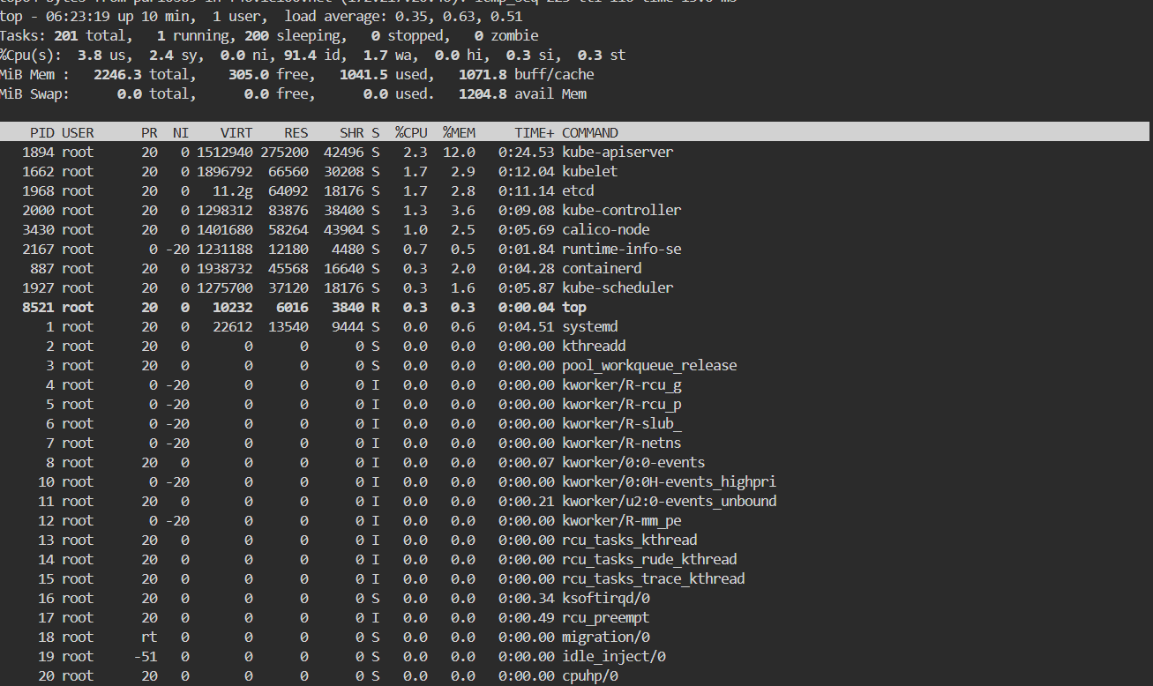

System commands:
What is uname?
uname stands for Unix Name.
It is a Linux/Unix command used to display basic information about the operating system and system kernel.
It helps you quickly identify what OS your machine is running and kernel-related details.
Output:
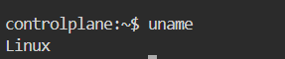
uname -r
What: Shows the current kernel version.
Why: Helps verify kernel updates or check compatibility with drivers/software.
Output:
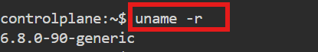

uname -a
What: Displays all system information (OS, hostname, kernel, architecture).
Why: Used when full system details are needed for debugging or support.

uptime
What: Shows how long the system has been running, number of users, and load average.
Why: Helps monitor system stability and workload.
Output:

uptime -p
What: Displays uptime in a pretty format (e.g., up 2 hours, 10 minutes).
Why: Easier to read when checking system running time.
Output:
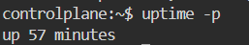

Hostname:
What: Displays the system’s hostname.
Why: Used to identify the machine in a network.
Output:
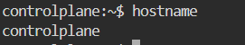

hostname -i
What: Shows the system’s IP address.
Why: Helps find the machine’s network address quickly.
Output:
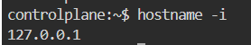

Timedatectl
What: timedatectl is a command used to view or manage the system date, time, and timezone settings.
Why: It helps you configure correct time and synchronization on Linux.
Output:
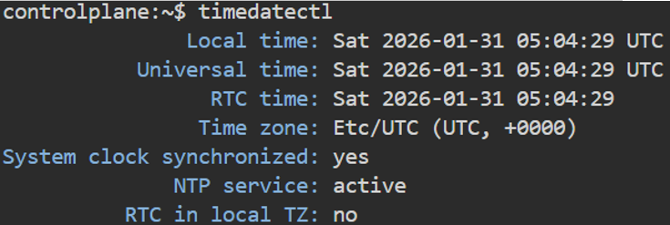

timedatectl set-timezone Asia/Kolkata
What: timedatectl set-timezone Asia/Kolkata is a command used to set the system timezone to Asia/Kolkata.
Why: It helps ensure the system time matches the local timezone.
Output:

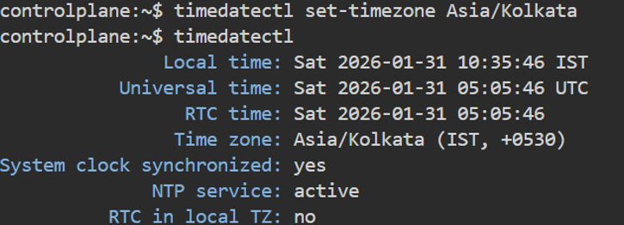

Ip addr
Explanation:
ip addr is used to display the IP address information of all network interfaces on a Linux system.
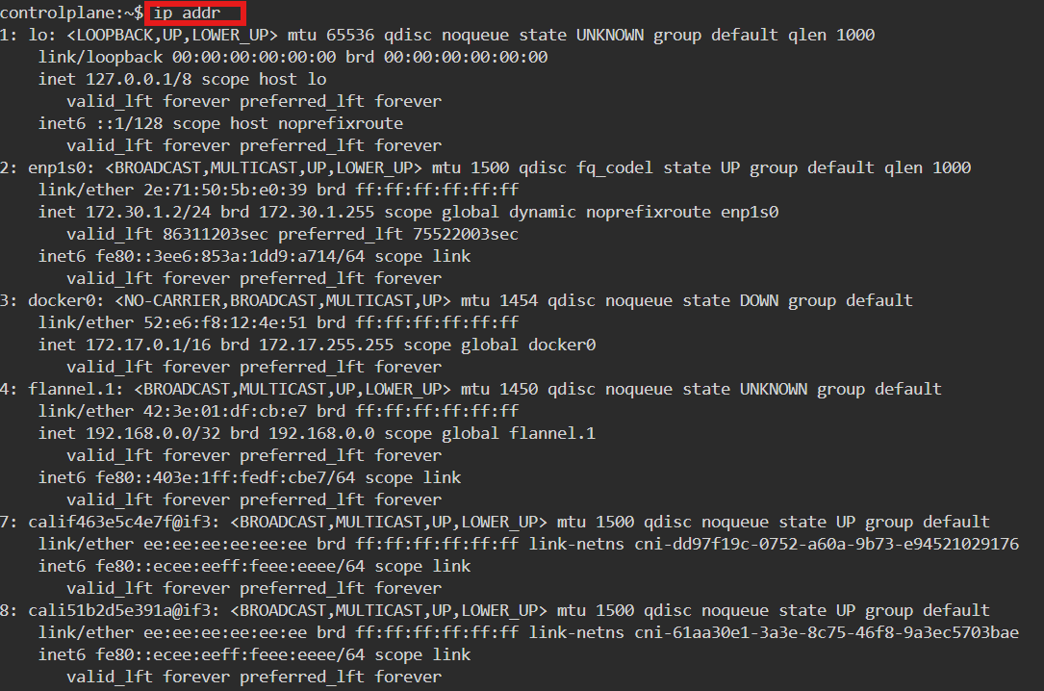
Description:
This command shows details such as:
• IP addresses (IPv4 & IPv6)
• Network interfaces (like eth0, ens33, lo)
• MAC address
• Interface status (UP/DOWN)

It is mainly used to check whether the system is connected to a network and to verify IP configuration.
This command is part of the iproute2 package and is the modern replacement for the old ifconfig command.

Ip route
Explanation:
ip route is used to display and manage the routing table of a Linux system.
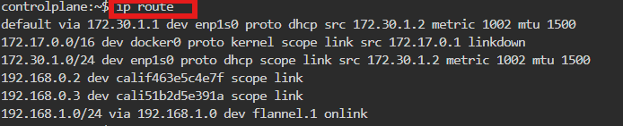
Description:
The routing table decides how network traffic is forwarded from your system to other networks.
This command shows:
• Default gateway
• Destination networks
• Which interface is used to send traffic
• Route priorities (metrics)

It helps you understand where packets go when you access the internet or another network.

Ifconfig
Explanation:
ifconfig is used to display and configure network interfaces in a Linux system.
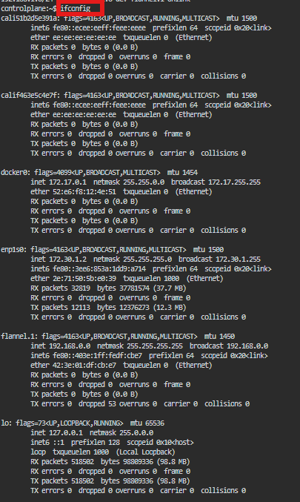
Description:
This command shows information such as:
• IP address
• Netmask
• Broadcast address
• MAC address
• Network interface status (UP/DOWN)
date
Explanation:
date is used to display the current date and time of the Linux system.

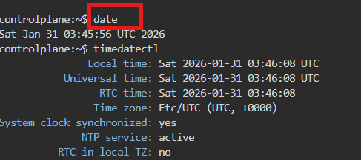
Description:
This command shows:
• Current date
• Current time
• Time zone information

It is commonly used to check system time, verify time zone, and timestamp logs or files.

Ps
Explanation:
ps is used to display information about currently running processes in a Linux system.
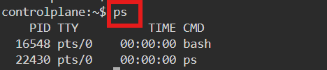
Description:
This command shows details such as:
• Process ID (PID)
• User who started the process
• CPU and memory usage
• Process status
• Command name

Kill -9 PID
Explanation:
kill -9 <PID> is used to forcefully terminate a running process using its Process ID (PID).
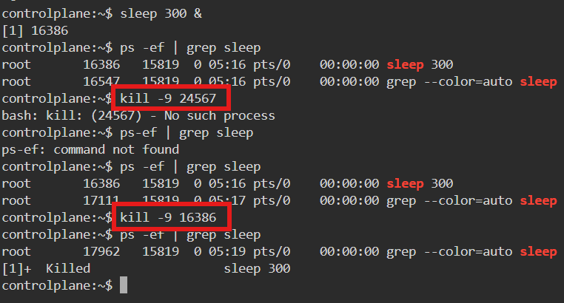
Description:
• kill sends a signal to a process
• -9 represents SIGKILL, the strongest signal
• It immediately stops the process without allowing cleanup

This command is used when a process is hung, frozen, or not responding to normal kill signals.
----------------------------------------------------------------------------------------------------
date : Shows system date and timestamp

date +”%d” : Prints the day of the month (01-31)

date +”%m” : Prints the month of the year 01-12

date +”%y” : Prints only the last two digits of Year

date +”%H” : Prints the hour 00-23

date +”%M” : Prints the Minute of the hour 00-59

date +”%S” : Prints the current seconds count in the minute (00-60)

date +"%D" : Prints Date in MM/DD/YY

date +”%F” : Prints only the Full date as YYYY-MM-DD

date +”%A” : Prints the Day of the Week Saturday-Sunday

date +”%B” : Prints the month between January-December

Output:
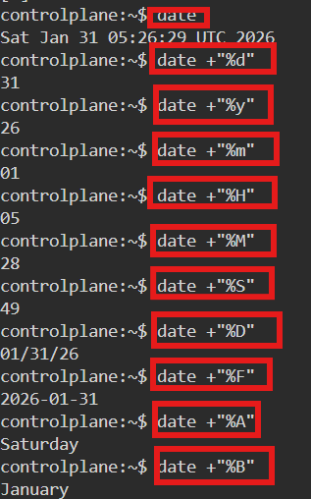

GREP (Global Regular Expression Print) commands:

What is grep -n "word" filename?
This command searches for a word and displays the matching lines along with line numbers.
Why use it?
Line numbers make it easier to edit or debug files after finding the match.

grep –i:
What is grep -i "word" filename?
This command searches for a word without case sensitivity (matches uppercase and lowercase).
Why use it?
Helpful when you are not sure about the capitalization of the text in the file.

grep –c:
What is grep -c "word" filename?
This command counts how many times a word appears in a file.
Why use it?
Useful for checking frequency of errors, events, or specific entries in logs.
Output:
